

Dave Merino

Web Development  
09953458131 | [daavviidd21@gmail.com](mailto:daavviidd21@gmail.com) | https://daavviidd21.github.io/dave2024portfolio/index.html

I’m particularly passionate about learning anything related to my field in Information Technology. I’ve worked as a Technical Support Specialist and as a Support Engineer for almost four years. Now, I’m transitioning my skills into web design/development. Willing to take new challenges with **strong problem solving**.

**SKILLS :**   
SQL Team Player  
POWER BI Goal-oriented  
REACTJS Desire for Continuous Learning   
HTML Data Analytics   
CSS

JAVASCRIPT  
TAILWIND

DATABRICKS

POSTGRESQL

SHOPIFY  
  
  
**WORK EXPERIENCE :**

**WEB Design/Developer (Shopify) –** Part time

* Design/develop visually appealing user-friendly website using HTML, CSS.
* UI/UX design and optimize them for responsiveness.
* Create and maintain design assests, including icons, banners and infographics to enhance website visuals.
* Testing and troubleshooting of web pages across various browsers and device.
* Exhibit proficiency in HTML, CSS and Javascript
* Collaborate across-function teams.

**TECHNICAL SUPPORT EGINEER (UGC/Loyalty and Rewards)**

Supporting Enterprise - Business park Cebu

March 2024 – September 2024

* Installing Plug-ins/widget to website
* Moderation of the plug ins
* Customize HTML, CSS and Javascript
* Databricks (SQL)
* Shopify moderation if needed (theme liquid files)
* Big Commerce moderation if needed
* Provide Support thru chats and emails
* Saleforce ticketing
* Jira

**TECHNICAL SUPPORT ANALYST**Goetu - Ortigas Center Pasig City

OCTOBER 2020 – January 2024

• Providing technical solutions to the client thru call

• Create ticket with the said issue (zoho and jira)

• Coordinate with other dept. with technical issue from technical analysis to resolution

**IT ASSISTANT**

Bread Talk - Business park Cebu

July 2019 – January 2020

• Responsible for Network, Hardware and Software trouble Shooting

• POS Maintenance

• CCTV Maintenance

• Hardware Installation

• Software/POS Installation

• Doing Remote troubleshooting for POS and software

**CERTIFICATIONS :**

**DATA ANALYST**: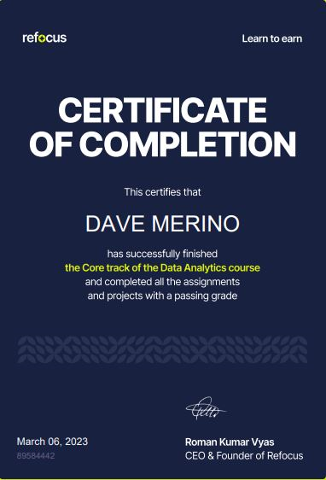Refocus Digital Academy

2022

(Data cleaning, Data visualizations, ETL)

